Project Lunar

(Name is yet to be declared)

L

Presented by NMG and Kneelbros

# Summary

Project Lunar is a space based mobile game. The setting of the game takes place in the vast universe, on many planets different than our own. The objective for the art direction of this game is to create a unique world for players to enjoy visually, and to experience a unique perspective of the different environments that the universe has to offer. These environments must be unique and original. Other pieces of work include the space craft, user interface elements and other mechanical objects and debris.

# Examples

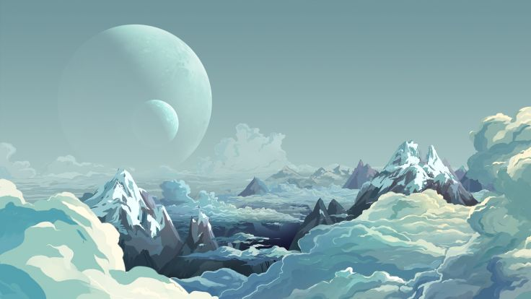Here are a few examples of what the landscape should look and feel like. The first example is primarily what we are looking for. A unique and vivid landscape with several elements, maintaining realism with a cartoonish style. Notice that the image gives a chilly and cold feeling, allowing the user to feel as if they were in a cold and icy planet. Elements such as the planets orbiting in the background are also key in providing the feeling of being outside of earth.

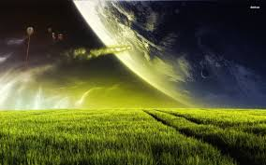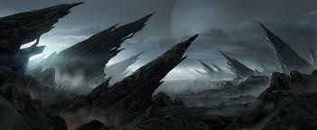

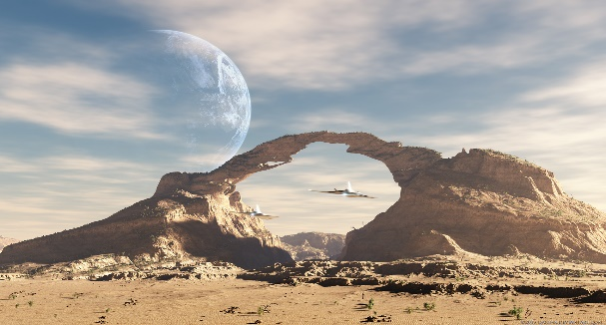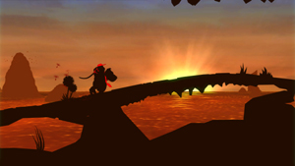

# Assets Required

In total, we are looking for about 5 different landscapes, all must be unique and have different elements, while maintaining a similar art style. Amongst these 5 landscapes, one concept drawing of a space pod will be required. The shape of this pod must be similar to the size and shape of these pods: But feel free to be more creative with the design. Note that the space pod should be in the same art style as the landscapes and must not look alienated. Lastly, the user interface elements will also an additional asset required. The user interface asset is optional but recommended. We would like you to be completely creative in the creation of the user interface elements but urge to follow a simple style.

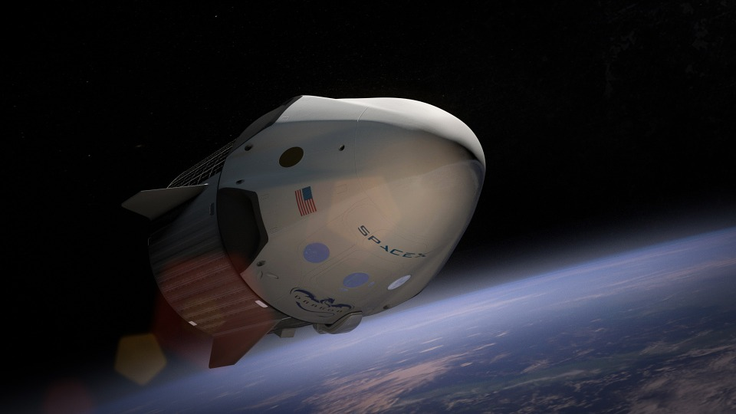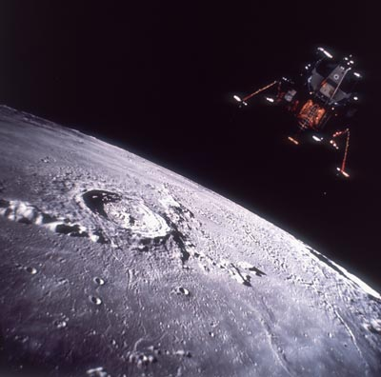

# User Interface Elements

If you choose to create UI elements as well, the buttons required are:

Start Game,

Main Menu,

Pause,

Resume,

Quit,

Facebook Button,

Twitter Button,

Settings,

Purchase Button (For store),

# Checklist

|  |  |  |
| --- | --- | --- |
| ASSETS REQUIRED | NUMBER OF ASSETS | NUMBER COMPLETED |
| Landscapes/Backgrounds | 5 |  |
| Space pod | 1 |  |
| User Interface Elements | 9+ |  |

# In-Game Scene

